**‘AccessBank DBA Internship Program’**

**Project 3: Backup databases using Maintenance Plan**

One of the most important task a SQL DBA does, and must be experienced in, is the process of backing up both the **system and user defined databases**. This project will test your knowledge in setting up that process. We will start of simply.

The following task has been assigned to you.

You have two **small** databases - HR and FinanceDB – and you have been given the task of implementing a backup plan for these **user defined** databases using the maintenance plan wizard.

**Backup plan:**

**FULL backup for HR and FinanceDB databases everyday at 04:00 AM and LOG backups every hour between 12:00 PM and 12:00 AM.**

You must firstly determine what the **sizes** of each database are. This script will help you

SELECT [Database Name] = DB_NAME (database_id),

[Type] = CASE WHEN Type_Desc = 'ROWS' THEN 'Data File(s)'

WHEN Type_Desc = 'LOG' THEN 'Log File(s)'

ELSE Type_Desc END,

[Size in MB] = CAST (((SUM (Size)* 8) / 1024.0) AS DECIMAL (18, 2))

FROM sys.master_files

GROUP BY GROUPING SETS

((DB_NAME (database_id), Type_Desc),

(DB_NAME (database_id)))

ORDER BY DB_NAME (database_id), Type_Desc DESC

GO

Then decide on which **recovery model** to use for each database. This script will help you to identify recovery model:

SELECT name, recovery_model_desc

FROM sys.databases

To change the recovery model use of the below queries:

USE master;

ALTER DATABASE model SET RECOVERY FULL;

USE master;

ALTER DATABASE model SET RECOVERY SIMPLE;

**Firstly, let’s look at databases’ recovery model by using that script:**

*SELECT name, recovery_model_desc*

*FROM sys.databases;*

**Then let’s change FinanceDB database’s recovery mode to Full by using following script:**

*USE master;*

*ALTER DATABASE FinanceDB SET RECOVERY FULL;*

**Now let’s verify it has changed.**

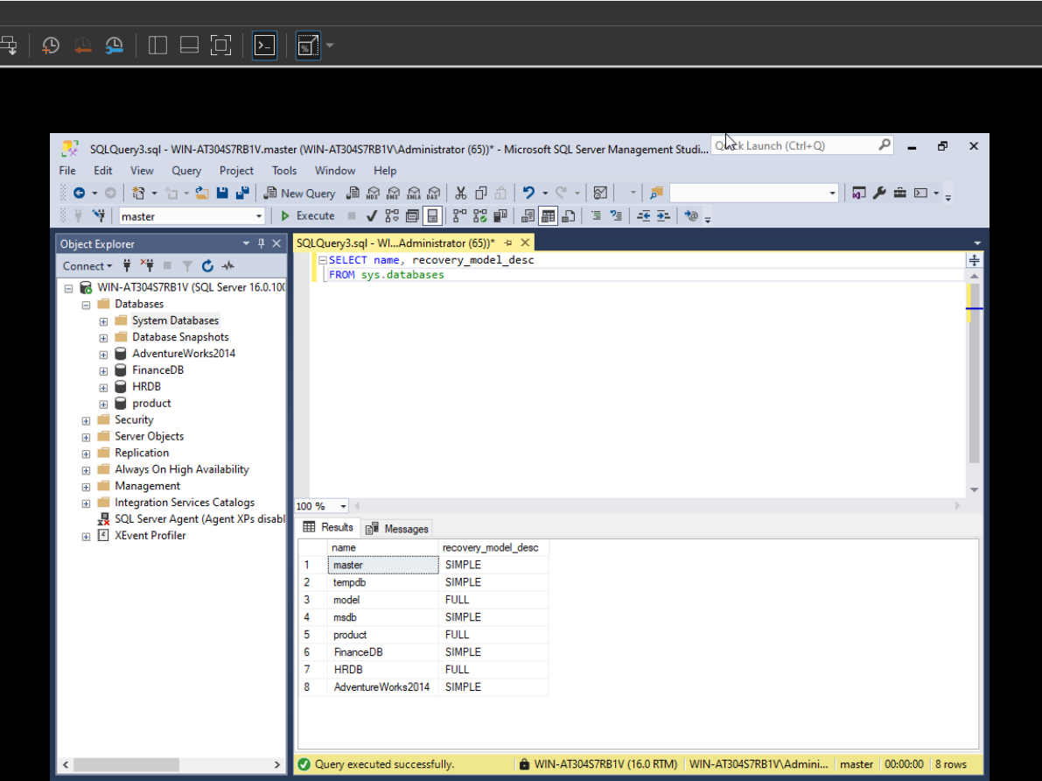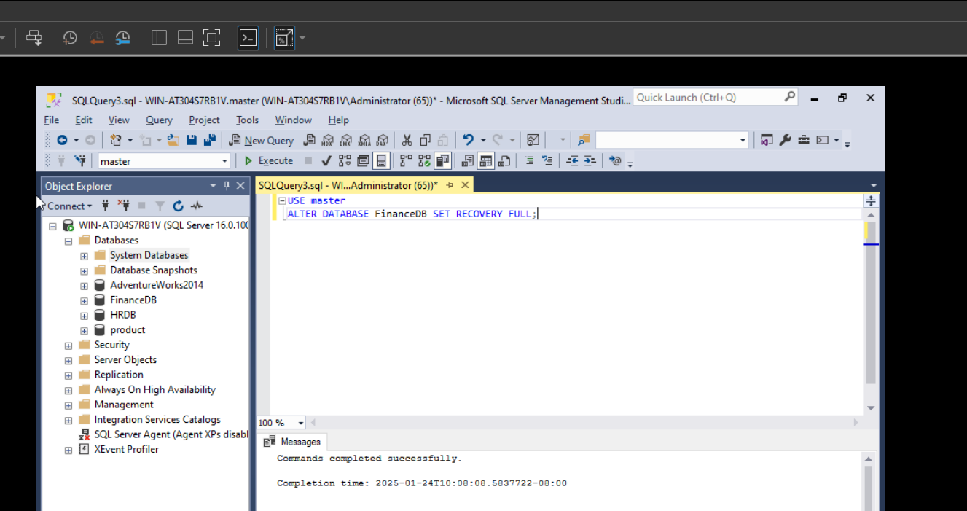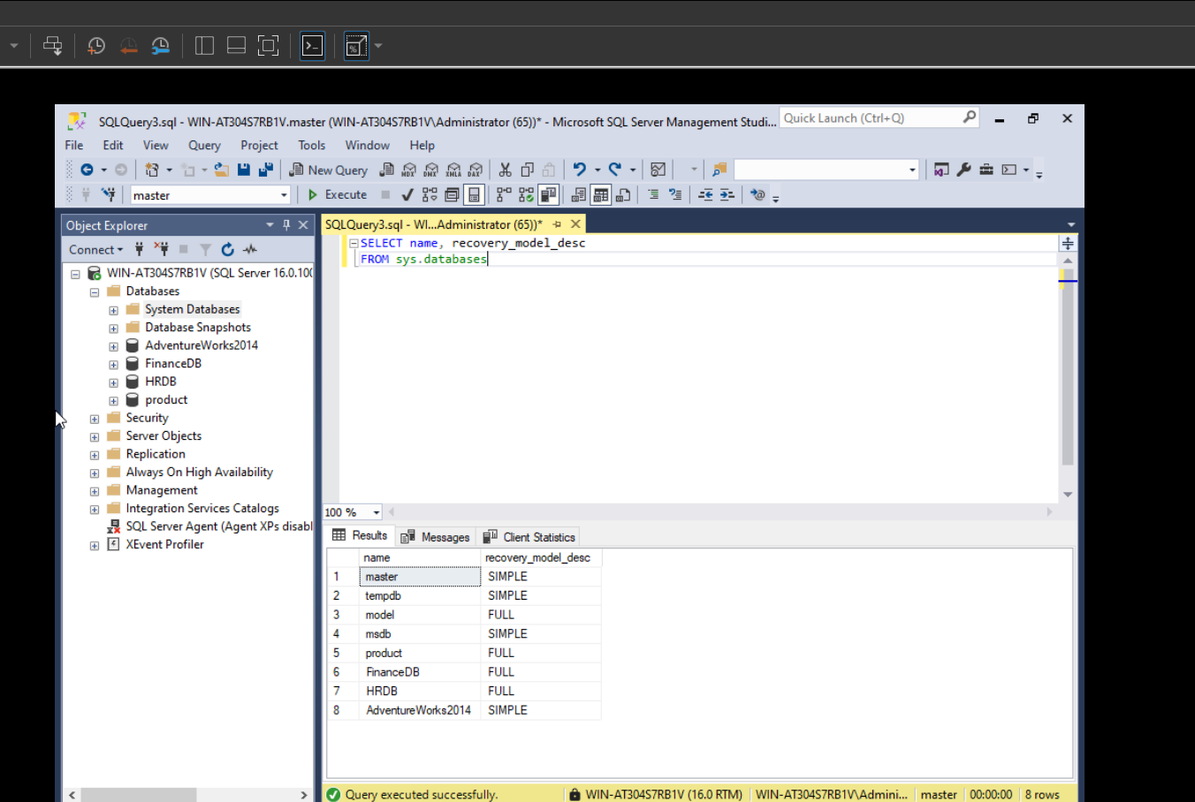

**Now let’s create new maintenance plan by using Management>New Maintenance Plan. I have to name it so in this example for simplicity I will call it HRDB and FinanceDB Backup and click OK. That will open up new query for us to design our plan.**

**Here I will drag and drop Back Up Database Task to my design section:**

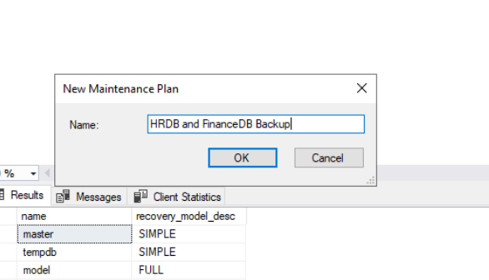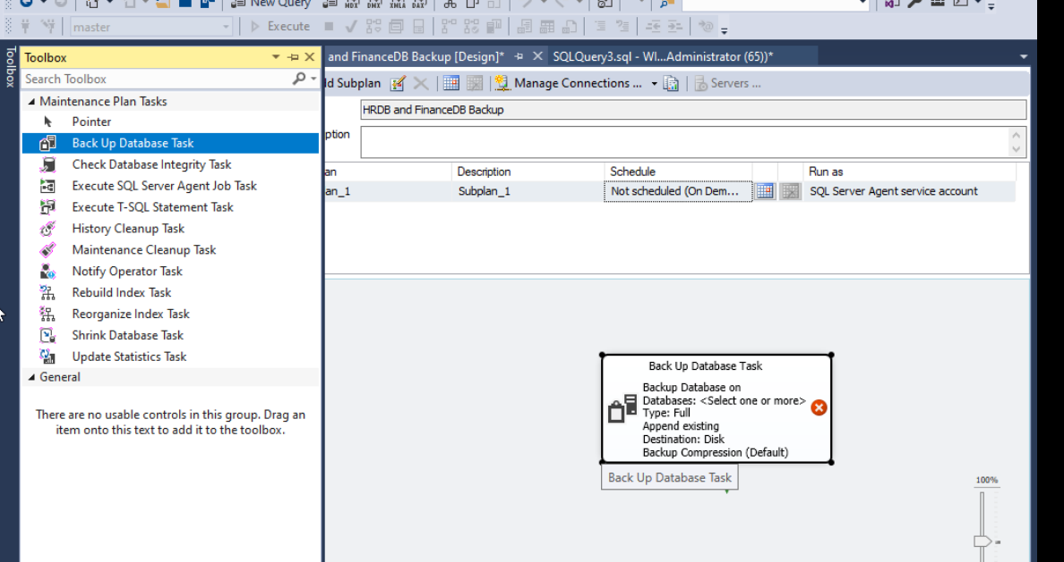

**Full backup type is selected by default so I will select databases for that task and check Ignore databases where the state is not online :**

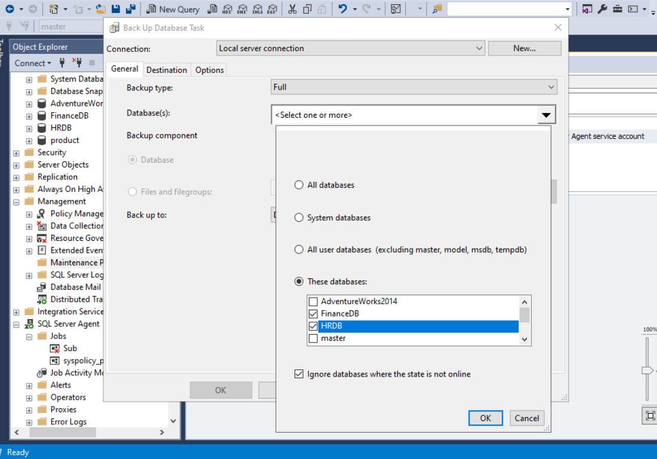

**Make sure to check Verify backup integrity in section Options:**

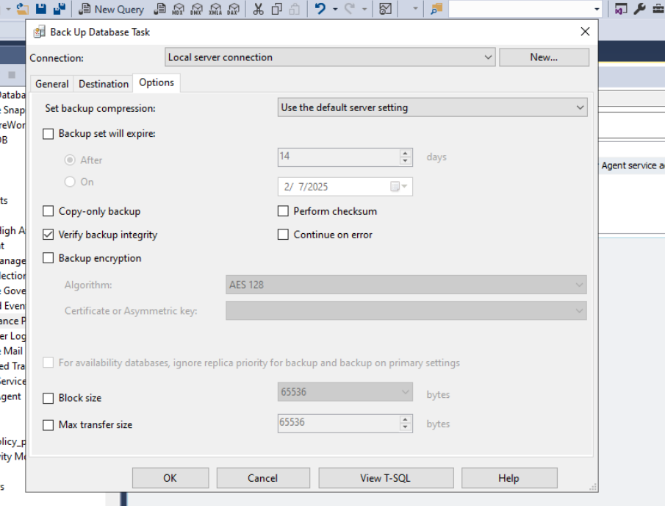

**Rename that subplan to FULL**: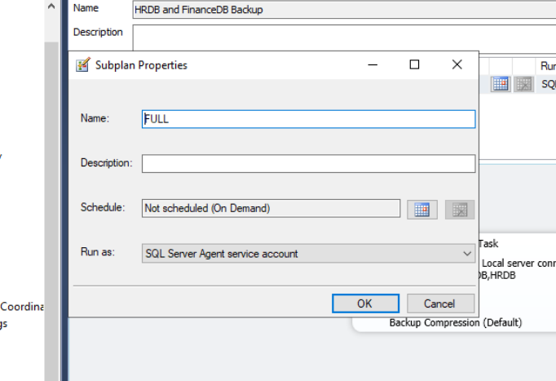

**Now let’s schedule it every day at 4 AM and click OK**: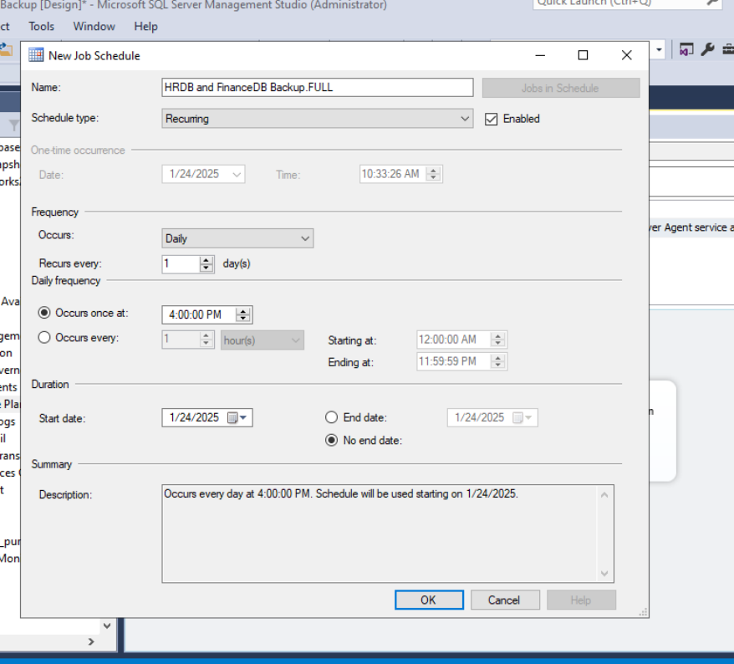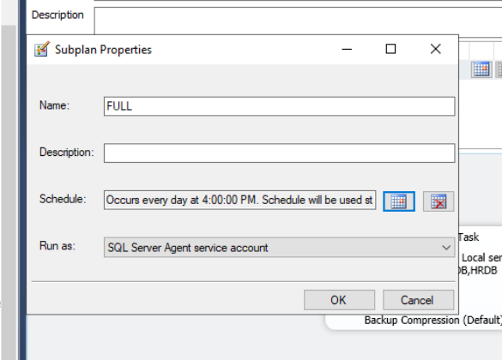

**Now let’s add another subplan and rename it to TLOG**: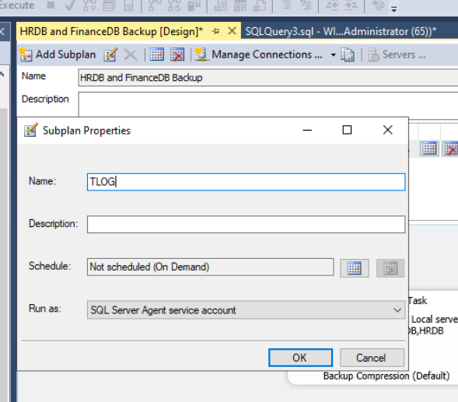

**Select Backup Type as Transaction Log and select databases and also make sure to check Ignore databases where the state is not online** :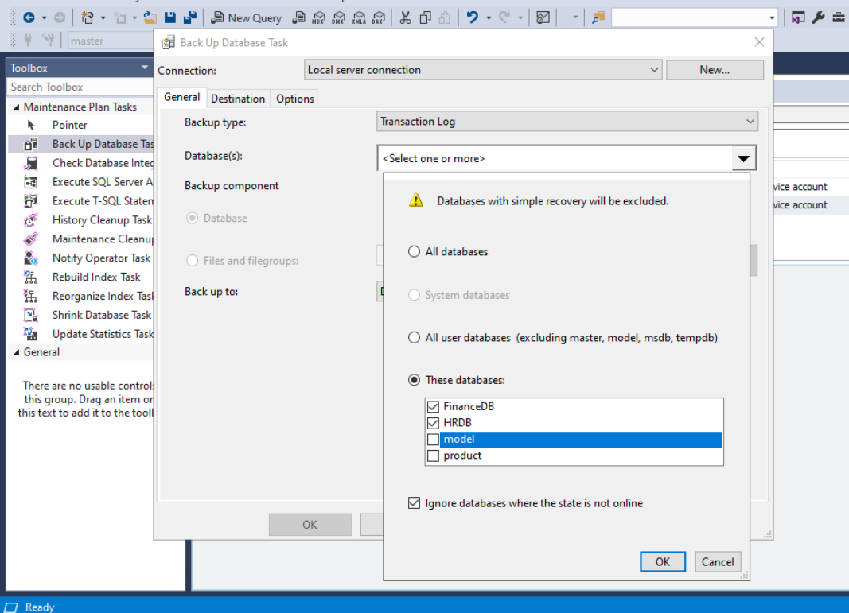

**Make sure to check Verify backup integrity too:**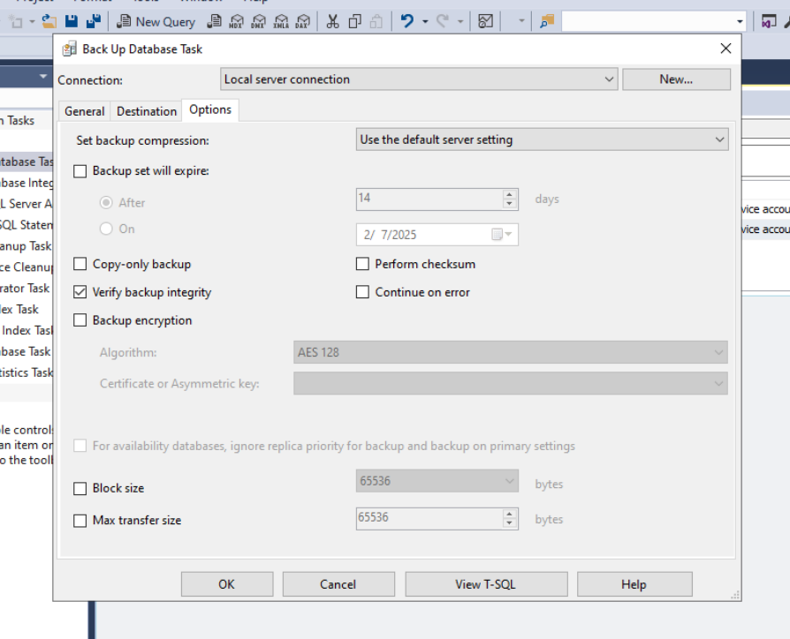

**Schedule it every day from 12 PM to 12 AM and click OK:**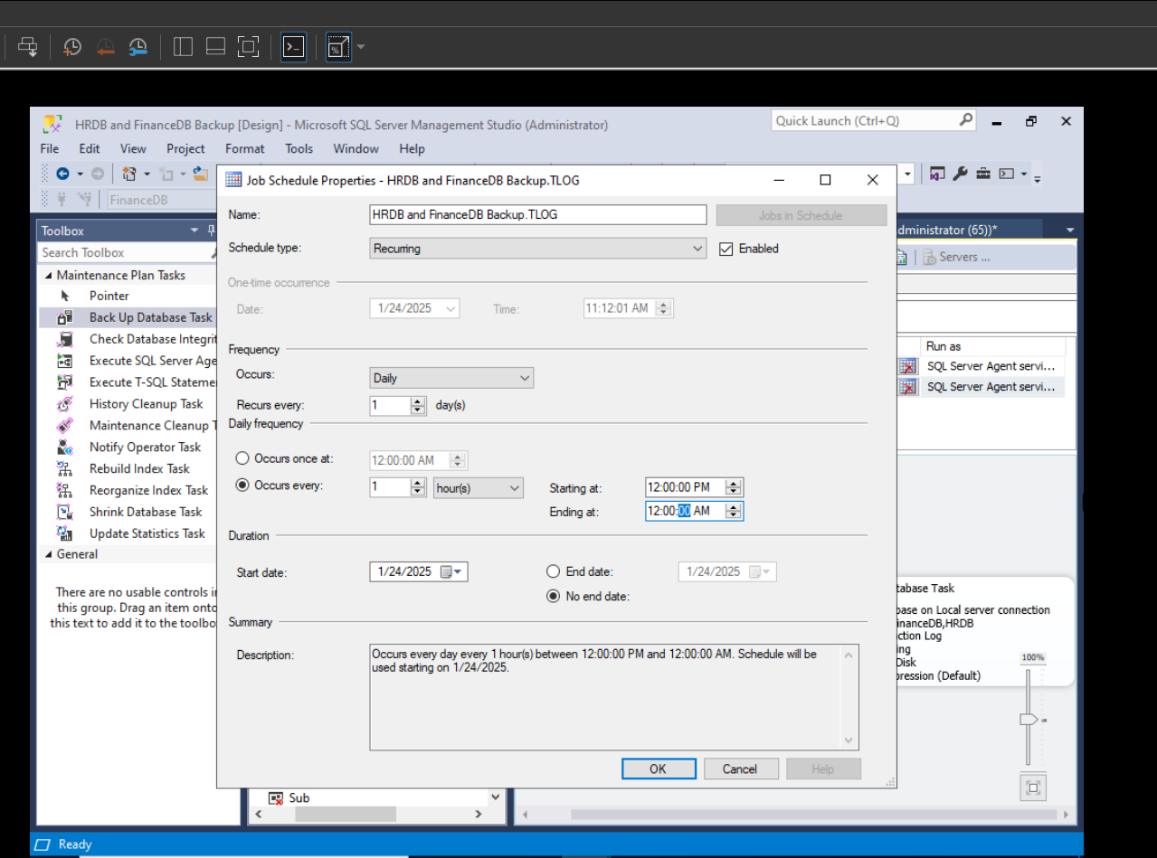

**Make sure to save it in that picture it’s not saved because there is star sign next to the name of the plan as a query in that example shows that it has not been saved**

**Just click CTRL+S combination to save it:**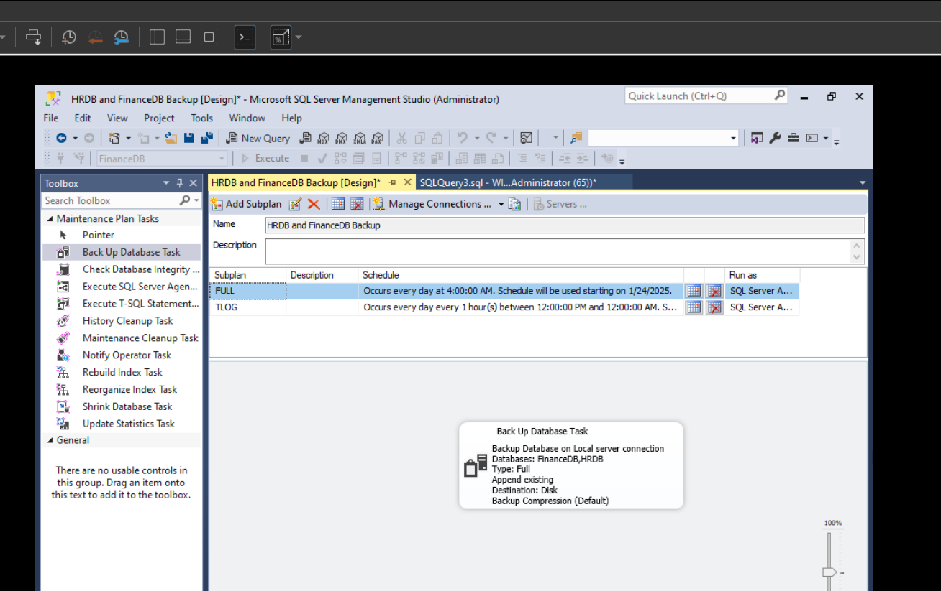

**After saving you will see it in Maintenance Plans section and your subplans in Jobs section for each of them:**

